**PROJECT DESIGN PHASE-II**

**DATA FLOW DIAGRAM &USER STORIES**

|  |  |
| --- | --- |
| **TEAM ID** | PNT2022TMID41966 |
| **TITLE** | IOT BASED SMART CROP PROTECTION SYSTEM FOR AGRICULTURE |
| **DATE** | 14.10.2022 |

**DATA FLOW DIAGRAMS:**

A Data Flow Diagram (DFD) is a traditional visual representation of the information flows within a system. A neat and clear DFD can depict the right amount of the system requirement graphically. It shows how data enters and leaves the system, what changes the information, and where data is stored.

**Example: (Simplified)**

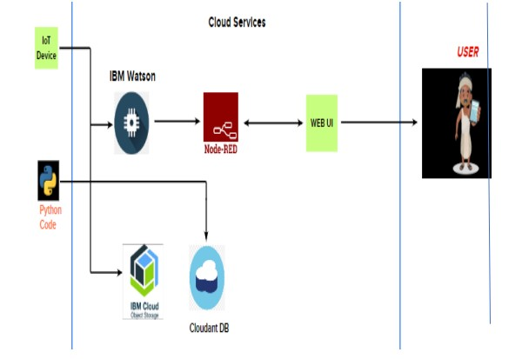

**DATA FLOW GRAPH (DETAIL):**

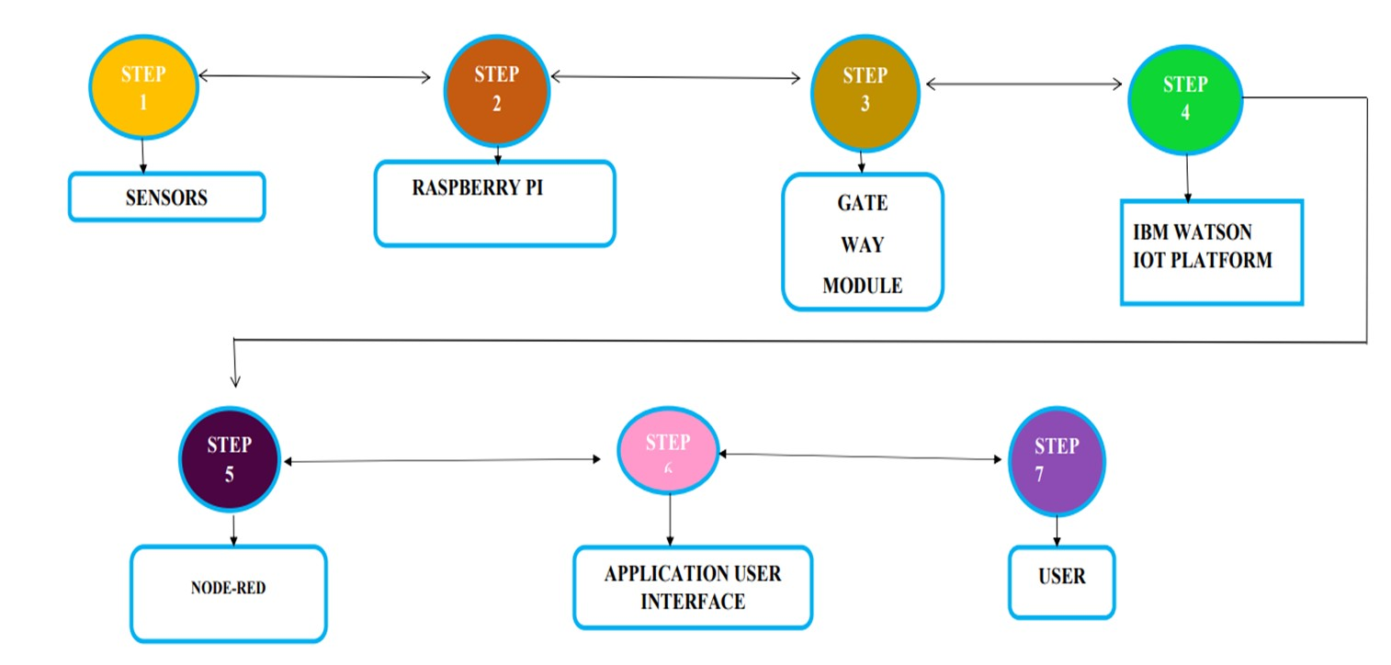

**USER STORIES**

Use the below template to list all the user stories for the product.

|  |  |  |  |  |  |  |
| --- | --- | --- | --- | --- | --- | --- |
| **User Type** | **Functional**  **Requirement (Epic)** | **User**  **Story**  **Number** | **User Story / Task** | **Acceptance criteria** | **Priority** | **Release** |
| Customer  (Mobile user) | Registration | USN-1 | User can register in application using their email id and password.  Finally conform that their login | I can access my account / dashboard | High | Sprint-1 |
|  |  | USN-2 | User can receive conformation mail after they can registered | I can receive confirmation email & click confirm | High | Sprint-1 |
|  |  | USN-3 | User can also register through facebook | I can register & access the dashboard with Facebook Login | Low | Sprint-2 |
|  |  | USN-4 | User also can register using gmail |  | Medium | Sprint-1 |
|  | Login | USN-5 | As a user, I can log into the application by entering email & password |  | High | Sprint-1 |
| Customer  (Field  Maintainer,  Owner) | Problem solutions | USN-3 | User can monitor the fields through remote mode | Checking Process. | Medium | Sprint-3 |
|  | Applications | USN-3 | As a user, I can respond to the problems in the fields immediately. | Continuous monitoring and remedial actions. | Medium | Sprint-3 |
|  | Final process | USN-3 | This proposed smart IOT based crop protection device is found to be cost effective and efficient. | I can take necessary action if required. | Medium | Sprint-4 |